**Exp 01.Create a simple cloud software application and provide it as a service using any**

**Cloud Service Provider to demonstrate Software as a Service (SaaS).**

**Aim**

To create a simple Movie Ticket Booking cloud application using Zoho Creator and provide it as a service over the cloud to demonstrate the Software as a Service (SaaS) model.

**Procedure**

1. Start and Login – Sign in to Zoho Creator with your Zoho account.

2. Create Application – Choose “Create New App” and select from template or build from scratch.

3. Design Forms & Reports – Add forms for input (e.g., user details, items) and reports for displaying data.

4. Add Logic/Workflows – Use Deluge scripts to automate actions like validation and notifications.

5. Set Roles & Permissions – Assign access levels to users for secure usage.

6. Deploy & Share – Publish the app, get the URL, and provide it to users as SaaS

**Output**

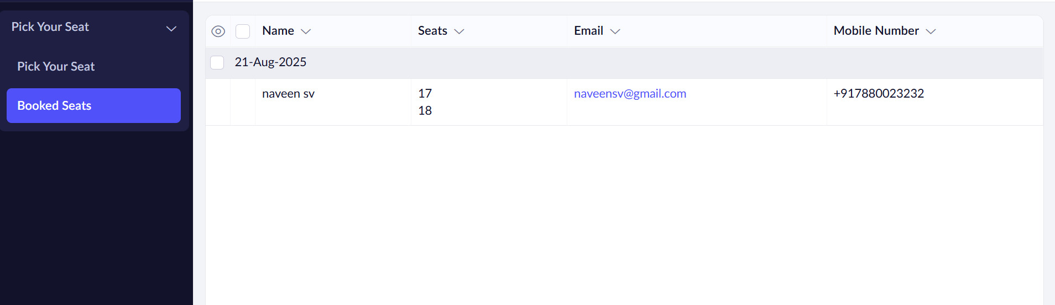

**Result**

Thus, a simple cloud-based application was successfully created and deployed using **Zoho Creator**, and it was provided as a **Software as a Service (SaaS)** model.